ERDF MA Guidance: WEBSITE PUBLICITY
If a beneficiary of an ERDF supported project has a website, the beneficiary shall inform the public about the support obtained on the website by displaying the EU logo and project description on the beneficiary’s website. These must remain on the website during the implementation period of the project.

EU LOGO

The EU logo must be visible on the landing page (on at least one digital device) of the beneficiary’s website without having to scroll and maintain this throughout the implementation period of the project. The landing page should be the beneficiary’s home page, the individual project page or the news page of the website.

The logo must be the full colour logo which includes the strapline and is to be of at least the same size and prominence as other logos on that page.

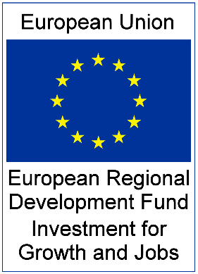

Where a website has been developed for the sole purpose of the project, then the logo and description must be on the homepage of this website.

PROJECT DESCRIPTION

A paragraph must be displayed, which should provide a short description of the project, proportionate to the level of support, including its aims and results, and highlighting the financial support from the EU. The description should help the uninitiated reader to at least have an idea about the ultimate goal of the project.

The paragraph in recognition of the ERDF support should be placed where it is easily accessible on the beneficiary’s website, for example home page, individual project page, news section etc. of the website.

INVEST NI EVIDENCE/VERIFICATION

Invest NI will retain evidence on file (using a snapshot of the website) that the logo and description are present prior to making the first claim payment).

Prior to making the final grant payment, Invest NI will again retain evidence on file (using a snapshot of the website) that the logo and description are present.

