Guidance for generating random numbers based on Claim value, No. of Invoices and Risk Rating
NOTE: Guidance for generating a specific quantity of random numbers can be found below or clicking on this link.
Step 1: Determine what the total expenditure value for the claims to be vouched and the total number of financial transactions which make up the total value of claims e.g. £100,000 value and 50 transactions.
Step 2: Determine the value of expenditure for the sample size required based on one of the following:-
5% sample of expenditure for a low risk project
10% sample of expenditure for a medium risk project
15% sample of expenditure for a high risk project
In this example a medium risk project should have a sample worth £10,000
NOTE: If unsure what the risk rating of your project is, please ask the Managing Authority.

Step 3: Click on the following link - http://www.random.org/sequences/
Step 4: Enter start (smallest No) & end (Largest No) range of the number of financial transactions which make up the total value of claims e.g. 1 & 50.
Step 5: If there are a large number of transactions enter 3 or 5 in the “Format in _ Column(s)” section to ensure number sequence is displayed on 1 page.
Click “Get Sequence” button - Transactions (Number Sequence) will be displayed in a random order.
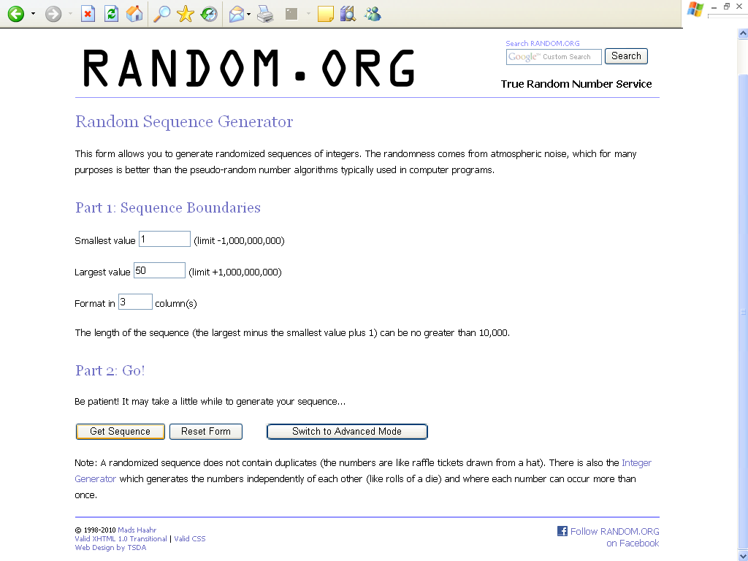
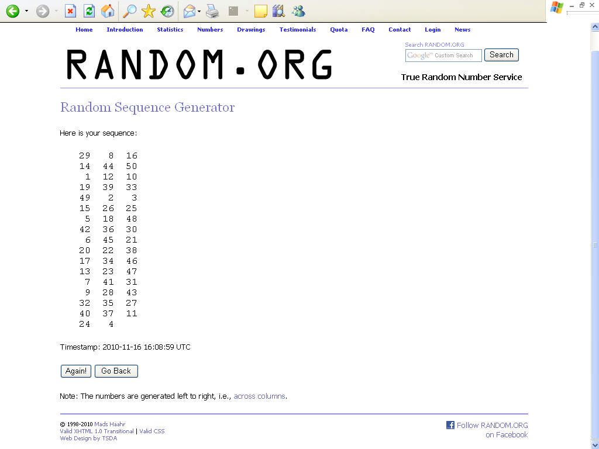
Step 6: Record the value of expenditure for the first number in the sequence relating to the appropriate transaction. Record an ongoing total value of expenditure working down each column for each particular claim/payment transaction sequence until you obtain an equal or greater than expenditure value relating to the risk sample in Step 2 above.
This will be your sample for verification.
IMPORTANT: Please print off the web page showing the number sequence (and timestamp) and then file to provide an audit trail for the sample taken.

PLEASE NOTE: There is a daily quota system in place on the amount of times you can use one of the generators (Based on Individual or Branch IP Address). You can always check your quota
Guidance for generating a specific quantity of random numbers.

Step 1: Determine what the total expenditure value for the claims to be vouched and the total number of financial transactions which make up the total value of claims e.g. £1,000,000 value and 500 transactions.
Step 2: Managing Authority have agreed that for specific schemes a set percentage of transactions can be vouched.
In this example a Scheme A has agreed with Managing Authority that 10% vouch of transactions can be carried out, therefore 50 transactions would need to be vouched
Step 3: Click on the following link - http://www.random.org/integers/

Step 4: For “Generate __ Random Integers” input number of transactions based on your percentage, in this example 50
Step 5: For “Each integer should have a value between ___ and ___” enter the range of numbers from the financial transactions which make up the claims, in this example - 1 & 500.
Step 6: If there are a large number of transactions enter 3 or 5 in the “Format in _ Column(s)” section to ensure number sequence is displayed on 1 page.
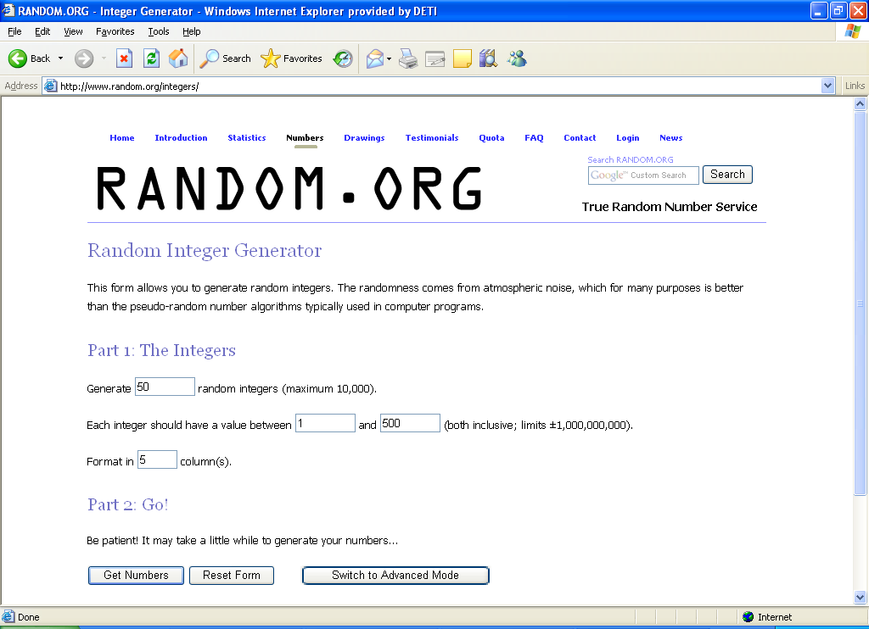

Click “Get Numbers” button - Transactions (Numbers) will be displayed in a random order.
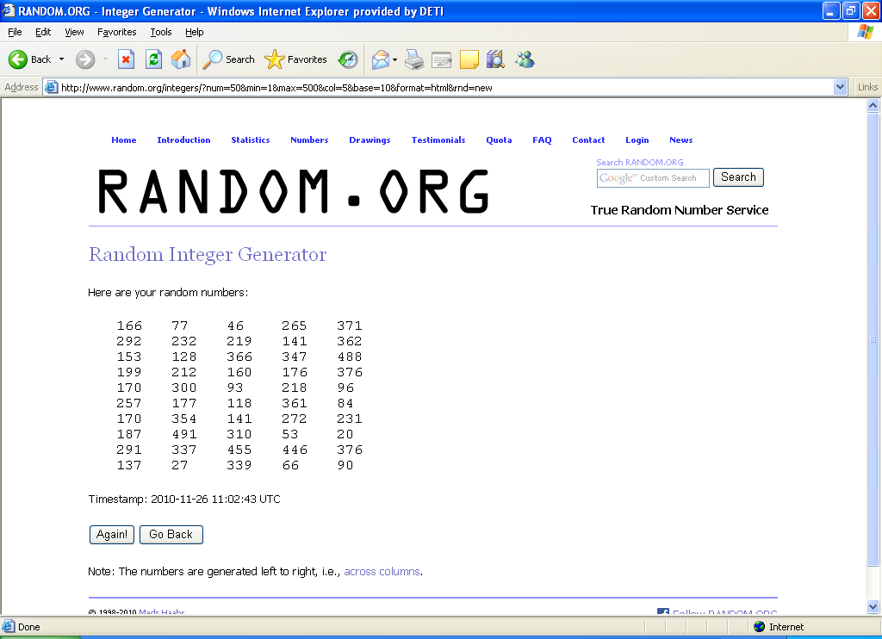
This will be your sample for verification.
IMPORTANT: Please print off the web page showing the number sequence (and timestamp) and then file to provide an audit trail for the sample taken.
PLEASE NOTE: There is a daily quota system in place on the amount of times you can use one of the generators (Based on Individual or Branch IP Address). You can always check your quota

Reviewed (no change) January 2015

