THE EUROPEAN SUSTAINABLE COMPETITIVENESS PROGRAMME FOR NORTHERN IRELAND 2007-2013

Managing Authority Publicity Guidelines
(Updated January 2015)

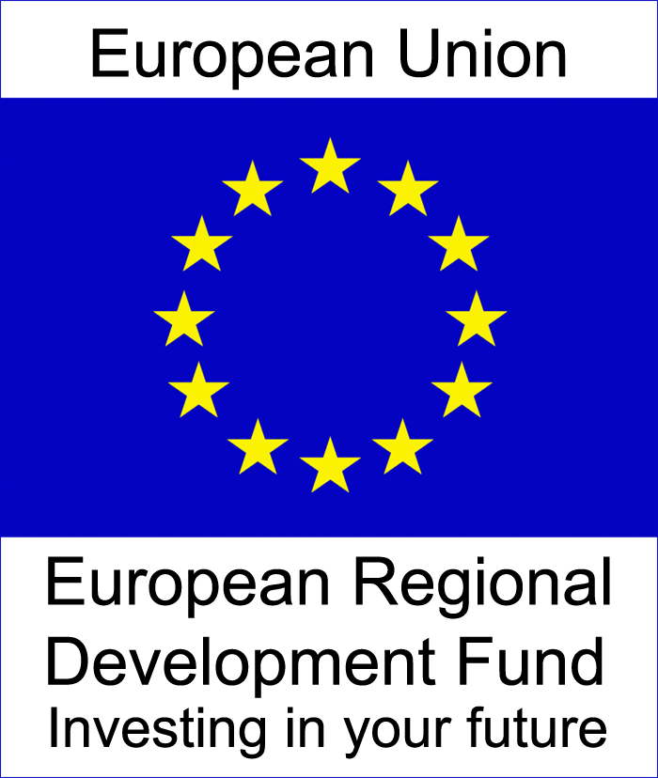

A Guide for Intermediate Bodies and Projects receiving funding under
The European Sustainable Competitiveness Programme for Northern Ireland
2007 - 2013

Purpose
The overall aim of publicity is to highlight and promote the role played by the European Union, specifically the European Sustainable Competitiveness Programme, in supporting projects within Northern Ireland.

The overarching publicity requirement for all projects is that those benefiting from the funding must be made aware of the contribution from the EU Programme. This can be achieved in a range of ways and is not limited to those outlined in this guidance. this guidance is designed to aid your information and publicity activities, not hinder them. It applies to all publications/printed material including:

- Invitations;
- Web-pages;
- Letterheads;
- Advertisements;
- Promotional items/materials;
- Billboards;
- Plaques;
- Contract, funding and other programme documents;
- Publications and press releases;
- Presentations.

Any conferences/seminars/fairs/exhibitions relating to activities supported by the Programme should also display the official logo prominently.

Logo

The logo at the top of this page is the official logo of the European Sustainable Competitiveness Programme for Northern Ireland. The official logo, which must not be edited or changed, can be downloaded from: http://www.eucompni.gov.uk/resource-library/downloads

All publicity material (leaflets, marketing, publications) being charged to the European Sustainable Competitiveness Programme for Northern Ireland 2007-2013 must include recognition of European Union funding. This should take the form of the official Programme logo and should also include a recognition line about the Programme as follows: “project part financed by the European Regional Development Fund under the European Sustainable Competitiveness Programme for Northern Ireland.”

Recognition given to the ERDF funding particularly the Programme’s logo, MUST always be at least equal to the logo/s and recognition given to other Project funders. Please use a common sense approach to the use of logos and recognition of EU funding.

It is also recognised good practice to place the ERDF logo on the front of the document/publication unless there is a justifiable reason to place it inside or on the back cover.

Other Points to Note about the Logo
- The official colour logo should be used – Pantone Reflex Blue for the surface of the rectangle and Pantone Yellow for the stars;

- Use of the black and white logo must be agreed with the Managing Authority in advance of publication; and

- The Managing Authority should be informed in advance of the launch of any projects and invites should issue to enable the attendance of officials where possible.

Specific Publicity Requirements
As an Implementer or Promoter of an ERDF funded project/operation you have specific publicity and information requirements. These are listed below:

- If you have a website (funded by the Programme) it should have the ERDF logo and a link to the DETI website.

- Proportionate and appropriate media events/publicity opportunities must be undertaken.

- Those taking part in the project/operation must be made aware of the ERDF funding received. This is something the Commission takes very seriously, so all participants and beneficiaries should know if the project is ERDF funded through the European Sustainable Competitiveness Programme for Northern Ireland.

- All publicity and information activities are to be recorded in progress reports.

- Prominent site signage must be displayed throughout the period of all infrastructure or construction projects with over €500,000 public contribution and must include the official logo with reference to the fund as follows “project part financed by the European Regional Development Fund under the European Sustainable Competitiveness Programme for Northern Ireland.” On billboards and plaques the official logo must be on the same scale as the logo/s of any other funder and the total EU reference should occupy 25% of the total space.

- Any project involving infrastructure, construction or the purchase of a physical object with a total public contribution to the operation which exceeds €500,000 must erect a permanent explanatory plaque within six months of completion.

- All recognition plaques supplied by the Intermediate Body or DETI must be erected in a prominent position.

Why are publicity and information requirements so important?
Non adherence to publicity and information requirements will be deemed an irregularity and may result in some or all funding being clawed back.

Ask yourself: “If an auditor visited our project, looked at our website etc would they immediately see that we had received funding from the European Regional Development Fund?”

Example
In 2005 the new Athens airport in Spata was fined €5 million (2%) for not having correct billboard information up during construction. The project was co-financed with €250 million from the Cohesion Fund.

Further information
This information note is only a brief overview of your publicity and information obligations. More guidance can be found at http://www.eucompni.gov.uk/resource-library/guidance

Please contact your funding body or the Managing Authority Communications Team should you have any queries about information or publicity.

The contact details for the Managing Authority are as follows:

The Publicity Officer
Competitiveness Programme Managing Authority
European Support Unit
Department of Enterprise, Trade and Investment
Room 47
Netherleigh
Massey Avenue
Belfast
BT4 2JP

Tel: 028 90529571
Textphone: 028 90529304

mailto:ERDFCompetitiveness@detini.gov.uk

Managing Authority

Issued March 2009
1st Revision November 2009
2nd Revision November 2012
3rd Revision January 2015

