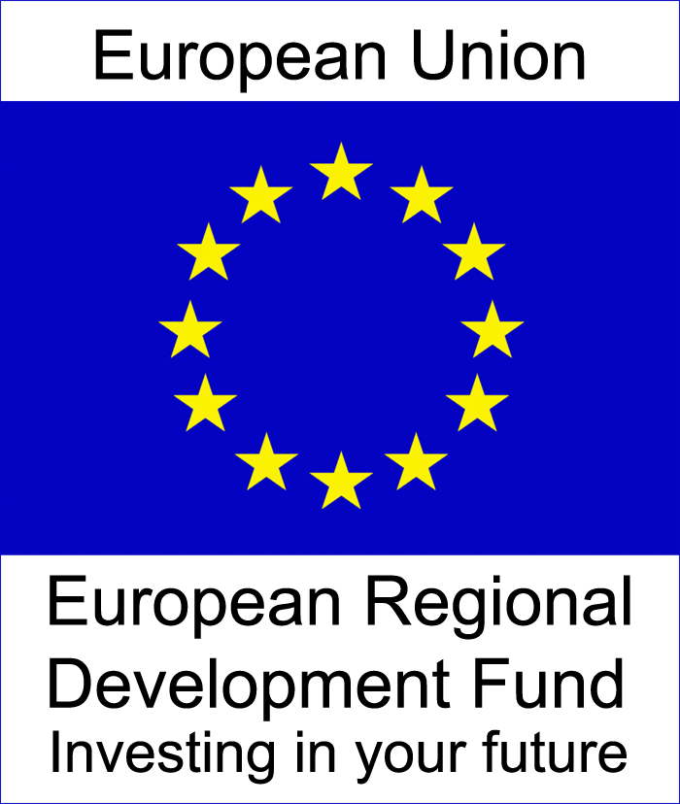

**Managing Authority Guidance for Risk Management and Sampling for Article 13 verifications**

**(Updated Jan 2015)**

# **Background**

1.1 This procedure sets out principles, concepts and recommendations for carrying out risk assessment. The principles of risk assessment and management contained in this document are primarily based on international internal audit standards (IIA) and comply with the appropriate EU best practice.

1.2 Once risks are identified and assessed they can be managed. The objective of risk management is to bring the risks of an organisation to acceptable levels by putting in place systems that can mitigate the likelihood of risk occurrence.

1.3 The purpose of this document is to provide guidance on risk management for the European Sustainable Competitiveness Programme for Northern Ireland 2007-2013 (“the Programme”) managed by the Department of Enterprise, Trade and Investment (DETI). This guidance should be read in conjunction with other relevant guidance on Article 13 and management verification requirements.

1.4 Article 13 requires the verification of expenditure and the objective of this document is to set out the rationale and methodology for the use of sampling and the determination of:

* The frequency and nature of on-the-spot verification checks on:
  1. Intermediate Bodies by the Managing Authority (MA) where the Intermediate Body is also the beneficiary; and/or
  2. Project Promoters by the Intermediate Bodies.
* The risk rating which will in turn identify the percentage of entries on the expenditure declarations to be checked against original audit trail documents.
  1. Expenditure will be vouched to the original documentation submitted. Although administrative verifications of 100% of the submitted claims are required by the Regulation, verification of each individual expenditure item and the related proof of delivery included in an application, although desirable, may not be practical. Therefore, selection of the expenditure items to be verified, where justified, may be carried out on a sample of transactions, selected taking account of risk factors (value of items, type of Promoter, past experience). The sampling method set out in this document should be used to identify the expenditure to be verified.

1.6 The overall strategy is to maximise the assurance levels within the confines of limited internal resources and ensure full compliance with Article 60 of Council Regulation 1083/2006. This is also to provide a reasonable assurance that statements of expenditure presented to the Commission are correct and as a consequence reasonable assurance that the underlying transactions are legal and regular.

1.7 The risk strategy should be reviewed, at least annually, to take into account changes in events and circumstances, for example major changes in management and control systems, results of audits, expected partial closures. Changes to the management and control system must be notified to the Audit Authority to enable inclusion of the detail of these changes in the Annual Control Report to the European Commission.

1.8 A definition of the different categories of risk is set out at Annex A.

**2.0 Risk assessment and on-the-spot verifications**

2.1 The following sections are intended to act only as a Best Practice guide by setting out some basic principles for consideration. Where possible, an annual timetable of on-the-spot verifications should be agreed and reviewed as regularly as required. There are a number of factors which need to be considered in determining the timing and frequency of on-the-spot verification.

2.2 The nature and specific characteristics of an operation will influence the risk assessment. This is reflected in the criteria and weighting set out below.

**3.0 Criteria for determining the risk rating for a project**

3.1 Criteria have been developed to determine the reliability of the systems of internal control which will in turn determine the risk rating of a project.

3.2 The risk rating will ultimately be used in two key ways:

* By the MA / Intermediate Body in planning the workload for the on-the-spot verification staff and setting annual plans for such work; and
* By the on-the-spot verification staff when extracting a sample of transactions to be verified and thereby identifying the expenditure to be examined during an on-the-spot verification.

3.3 There will be 3 risk ratings applicable to each project:

* Low;
* Medium; and
* High

## **4.0 How to determine the risk rating**

4.1 The risk rating for each project will be determined on the basis of an assessment of risk factors that will have a score from 1 to 5. These risk factors will be weighted to reflect the potential impact.

4.2 The MA has determined that the criteria for assessing risk rating shall include a quantified assessment of all key elements of the system.

4.3 The following factors will be applied in determining the risk rating at project level. The weighting for each is in brackets.

* Funding (15);
* Anticipated volume and value of financial transactions (20);
* Nature of the beneficiary (20);
* Track record of the beneficiary (25); and
* Nature of Project (20).

4.4 It is proposed that where checks do not cover 100% of expenditure then the sample size should be determined using the score calculated and the corresponding risk rating. The risk matrix to be used is set out in Annex A.

1. **Application of the risk scoring**

5.1 The percentage of expenditure to be checked under each of the ratings described below was determined by the Managing Authority at the outset, based on the data available. This will be examined as part of the annual risk review.

* Low risk – The project will be subject to ongoing first level management verification checks by the IB and at least one on-the-spot second level verification of the project by MA covering a 5% sample of expenditure.
* Medium - The project will be subject to ongoing first level management verification checks by the IB and at least one on-the-spot second level verification of the project by MA covering a 10% sample of expenditure.
* High - The project will be subject to ongoing first level management verification checks by the IB and at least one on-the-spot second level verification of the project by MA covering a 15% sample of expenditure.

5.2 While the risk matrix will be used to evaluate the risk of projects, management should consider any other information (such as previous Internal Audit or NIAO reports, findings during earlier verification visits etc) to revise (usually increase) the overall risk rating. A justification of any changes should be documented.

## **6.0 How to select the transactions for random verification, based on statistic sampling**

6.1 An online software application will be used for selection of random numbers. The random number generator web address and guidance on its use is available under the Guidance section of the Programme website. The transactions selected by the application from reimbursement claims will be saved for audit trail purposes.

**Annex A**

**Risk Matrix**

|  |  |  |  |
| --- | --- | --- | --- |
| **Project Name and Reference number** |  | | |
|  | **Score** | **Weighting** | **Total** |
| 1. Programme Funding Awarded |  | 15 |  |
| 1. Volume and value of transactions |  | 20 |  |
| 1. Nature of the beneficiary |  | 20 |  |
| 1. Track record of the beneficiary |  | 25 |  |
| 1. Nature of project |  | 20 |  |
| **Total** |  | | |
| **Risk Rating (enter Low, Medium, High)** |  | | |

|  |
| --- |
| Notes: |

Notes should include any assumptions made, references to relevant audit reports, findings from previous verification visits, justification if revising overall risk rating etc.

Risk Assessment Completed by ________________________________

Date: _______________________

**Risk Assessment Criteria and Scoring**

1. Programme Funding Awarded

|  |  |
| --- | --- |
| **Range** | **Score** |
| Up to £100,000 | 1 |
| £100,001 - £500,000 | 2 |
| £500,001 - £1,000,000 | 3 |
| £1,000,001 - £4,000,000 | 4 |
| Over £4,000,000 | 5 |

1. Volume and value of transactions (use highest score applicable to each project)

|  |  |
| --- | --- |
| **Range** | **Score** |
| Low number (<100) of low value (<£1,000) transactions | 1 |
| High number (>100) of low value (<£1,000) transactions | 2 |
| Low number (<100) of medium value (£1,001-£10,000) transactions | 3 |
| High number (>100) of medium value (£1,001-£10,000) transactions | 4 |
| Any number of high value (>£10,000) transactions | 5 |

Note: Number of transactions = total estimated invoices over the lifespan of the scheme or project

3. Nature of Beneficiary

|  |  |
| --- | --- |
| **Description** | **Score** |
| Government Department | 1 |
| Non Departmental Public Body | 2 |
| Local Authority | 3 |
| Public Body | 4 |
| Private company/Company limited by guarantee/Charitable organisation | 5 |

4 Track record of Beneficiary

|  |  |
| --- | --- |
| **Description** | **Score** |
| Promoter with relevant prior EU funding experience and few problems | 1 |
| Promoter with relevant prior EU funding experience with some problems/errors detected;  or  Promoter with limited relevant prior EU funding experience;  or  Promoter with no previous experience but where verifications have revealed no significant errors/weaknesses | 3 |
| Promoter with no relevant EU funding experience | 5 |

5 Nature of Project

|  |  |
| --- | --- |
| **Description** | **Score** |
| Single contract for delivery of product/service | 1 |
| Large proportion of expenditure incurred through award of contract | 2 |
| Expenditure is mixture of award of contract and direct real costs (salaries etc.) | 3 |
| Large proportion of expenditure based on actual costs to include salaries, overheads, travel and subsistence etc. | 4 |
| All expenditure based on actual costs to include salaries, overheads, travel and subsistence etc. | 5 |

Risk scores will therefore be in the range 100 – 500 and will correspond to ratings as follows:

|  |  |
| --- | --- |
| **Risk Score Range** | **Risk Rating** |
| 100 – 233 | Low |
| 234 – 366 | Medium |
| 367 – 500 | High |

## **Annex B**

##### 1.0 Risk definition

1.1 A **risk** is defined as a possible danger to a system or entity that certain event(s), action(s) or lack of action(s) which, if they occur, may endanger assets and/or the reputation, or the achievement of objectives in any part of the system/entity.

1.2 Risk management is a cyclical, ongoing process which includes identifying, assessing, prioritising risks, planning, implementation and review of mitigating or corrective actions.

1.3 In managing risks, regard should be given to **internal factors** (such as the quality and motivation of the staff, turnover of staff, quality of control systems and rapid growth of workload) and **external factors** (such as the existing legal environment and the possibility of changes in legislation, technological developments, capability of institutions to carry out the duties that are delegated to them and the general risk environment in which the organisations are operating).

**2.0 Risk Classification**

2.1 Distinction can also be made between inherent risks and control risks. The way in which the MA needs to consider and manage these risks is also therefore distinct.

2.2 **Inherent risk -** is the susceptibility of the management system to factors arising from the environment in which it operates, such as national rules, regulations and the working environment. Examples of inherent risks which could impact on the Northern Ireland Programme include:

* + Changes in Regulations and/or legislation;
  + Review of Public Administration;
  + Budget cuts at Member State or Department levels;
  + Operation and/or functionality of the database; and
  + Risk of losing paper files and records in the event of a fire or other disaster.

2.3 These inherent risks are mainly managed at Member State or Corporate level and do not therefore factor in to the calculations and risk scoring methods devised and described later in this paper.

2.4 **Control risk** - is the risk that internal control systems are less than adequate to ensure the funds are used economically and efficiently and for the purpose intended, and that the use of funds is properly reported. Examples of control risks which could impact on the delivery of the Programme include:

* Efficiencyrisk - Inefficient procedures and processes;
* Human resources – lack of adequately trained staff;
* Cashflow risks; and
* Fraud risk – including conflicts of interest or inadequate segregation of duties.

2.5 These control risks are managed through a variety of mechanisms which include the Memoranda of Understanding (MoU) between the MA and Intermediate Bodies, guidance notes, training, audit review and planned MA checks on compliance with the MoU terms and conditions. Therefore these factors will only be considered to a degree in determining the nature and frequency of on-the-spot checks.

DEC 2010

Revised JAN 2015