

The European Sustainable Competitiveness Programme for Northern Ireland 2007-2013

DETI Audit Authority Checklist

for completion of

Audits of Operations

under

Article 16 of Commission Regulation (EC) No 1828/2006

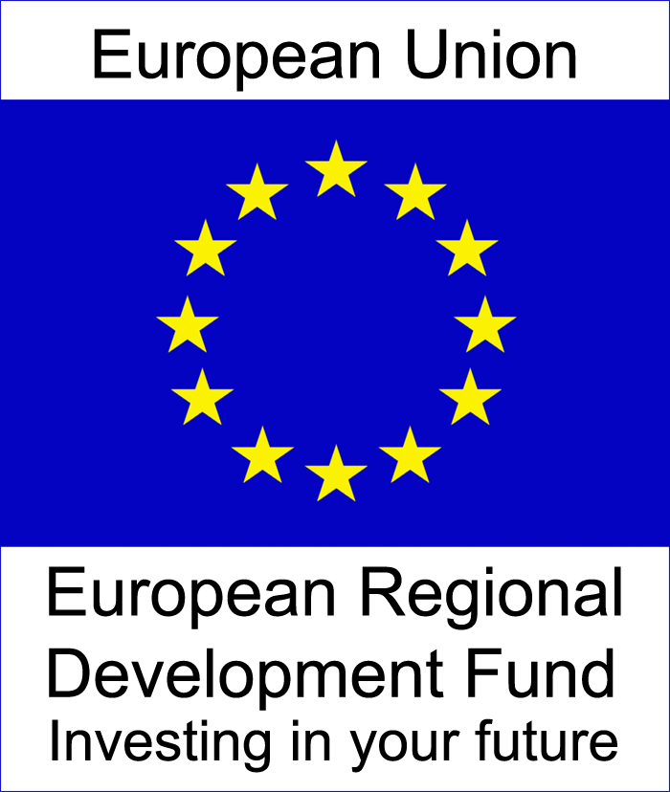
General Information
Date(s) of Audit:
Location(s):
Auditor(s):
Priority Number and Title:
Sub-Sub-Priority Number and Title:
Project Number and Title:
Short Description of Project:
Contact Details (IB and Project):
Details of Previous A13/A16 Reports, including Outstanding Issues:
Claim(s) Period and Value (£’s):
Value of ERDF in Claim(s) (£’s):
Prepared By and Date:
Reviewed By and Date:
Reviewed By and Date (AA):

Source/ Regulation | No | Audit Step |  | Yes |  |  | No |  |  | N/A |  |  | Comment |  |  | Ref
Section 1 - Eligibility of Operation and Beneficiary
1. Please read carefully the project application as well as the project approval documents. Note any points (subsidy rate, State aid, income generation,..) and expenditure categories that may carry a particular risk.
2. It is necessary to read beforehand the description in the OP/SPD, Commission's State Aid decisions, national laws and implementing rules.
OP/National rules/Call for interest | 1.1 | Has the Scheme been selected in accordance with the criteria agreed by the Programme Monitoring Committee (TRIM Record DT1/09/0300243 and Section 4.3 of the Operating Manual for the EUSCP refer), ie:
  Criterion | Priority | Max score
  Potential to increase level of innovation | 1 only | 60
  Potential to increase level of enterprise and entrepreneurship | 2 only | 60
  Potential to promote sustainable development and create sustainable communities (accessibility) | 3 only | 60
  Fit with Technical Assistance Indicative Activities | 4 only | 60
  Viability and additional benefits of application | All | 30
  Competence of promoter | All | 20
  Demonstration of value for money and wider economic benefits of application | All | 20
  Ability to deliver priority objectives as specified in Operational Programme | All | 40
  Equality and good relations [Cross-Cutting theme] | All | 15
  Promoting sustainable development and the creation of sustainable communities [Cross-cutting theme] | All | 15
 | 1.2 | Has the Scheme been selected in accordance with the Managing Authority Operating Manual Sections 4.3 to 4.6, ie:
 | (a) | Proposal submitted detailing Scheme description, anticipated framework for implementation of the Scheme, profile of spend per year, Casework Submission/Business Case, Development Path Analysis (DPA) and Equality Impact Assessment (EQIA)?
 | (b) | Selection Panel, consisting of at least 3 members, scored the Scheme at least 130 out of 200 (65%) and scoring sheet(s) signed by all members?
 | (c) | Memorandum of Understanding (MoU) or Grant Award Letter signed by all parties?
 | 1.3 | Has the Project been selected in accordance with the criteria agreed by the Programme Monitoring Committee (TRIM Record DT1/09/0300243 and Section 4.3 of the Operating Manual for the EUSCP refer), ie:
  Criterion | Priority | Max score
  Potential to increase level of innovation | 1 only | 60
  Potential to increase level of enterprise and entrepreneurship | 2 only | 60
  Potential to promote sustainable development and create sustainable communities (accessibility) | 3 only | 60
  Fit with Technical Assistance Indicative Activities | 4 only | 60
  Viability and additional benefits of application | All | 30
  Competence of promoter | All | 20
  Demonstration of value for money and wider economic benefits of application | All | 20
  Ability to deliver priority objectives as specified in Operational Programme | All | 40
  Equality and good relations [Cross-Cutting theme] | All | 15
  Promoting sustainable development and the creation of sustainable communities [Cross-cutting theme] | All | 15
 | 1.4 | Has the project been selected in accordance with the Managing Authority Operating Manual Sections 4.9 to 4.11, ie:
The manual is available at http://www.eucompni.gov.uk/uploads/files/operating_manual_2.1.pdf
 | (a) | Standard application form submitted, supported by a Casework Submission/Business Case containing: outline of the project proposal, commercial/economic and technical objectives, how the project will address the key objectives of the scheme, timetable and milestones, project design details, proposed methodology and project management structures, environmental and equality issues including DPA, detailed costs and sources of funding, key risks, under/additional value funding will deliver and projection of benefits to Northern Ireland (NI)?
 | (b) | Selection Panel/Casework Committee, consisting of at least 3 members, scored the project at least 130 out of 200 (65%) and scoring sheet(s) signed by all members?  In respect of Invest NI only, the following signatories are appropriate (these procedures were phased in between May and November 2010, therefore, the delegation in the attached PDF file may apply):  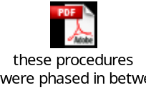
  Total Assistance Proposed | Delegated Approval Authority
  >£1million | Board Casework Committee (3 members)  Two Board Members plus one Top Management Team (TMT) member. Chaired by a Board Member.
  >£500k - £1m | Senior Executive Casework Committee* (3 members)  One MD plus two Directors / G6’s from separate divisions.
  >£100k - £500k | Executive Casework Committee*  One Director/G6 and two G7s from separate divisions
  >£50k - £100k | Manager Casework Committee*  One (divisional) G7 and one G7/DP from outside that division.
  < £50k | Line Manager.
  * Committee Chairs to be from outside the division presenting the case.
  Notes
  - Any project or programme requiring DFP approval will also require Ministerial approval.
  - An advisory Senior Executive Casework Committee will consider all cases proceeding to Board Casework.
  - For ERDF supported projects a scoring sheet against agreed criteria and a development path analysis (DPA) defining the sustainability aspects of the project must be completed, and submitted as part of the casework documents for consideration at the approval stage.
 | (c) | Eligibility - Project will occur exclusively in NI (or benefits will be specific to NI), has been submitted in the required format, application has met the deadline for receipt if the subject of a call and the proposal is State Aid compliant?
 | (d) | An Economic Appraisal has been submitted to, and approved by, DFP and the Minister, where appropriate - see attached delegated limits?  
1083/06 A55 | 1.5 | Is this a revenue-generating project? If yes, was the grant rate calculated in accordance with Article 55? (A revenue-generating project means any operation involving an investment in infrastructure the use of which is subject to charges borne directly by users or any operation involving the sale or rent of land or buildings or any other provision of services against payment).
1083/06 A39-41, A78.4 | 1.6 | Is this a major project? If yes, was it approved by the Commission? (A major project is a series of works, activities or services intended in itself to accomplish an indivisible task of a precise economic or technical nature which has clearly identified goals and whose total cost exceeds €25 million in the case of the environment and €50 million in other fields).
OP National rules Call for interest | 1.7 | Is the project eligible according to the objectives of the Priority (compare the Priority description in the OP, in the national laws or implementing guidelines with the project application)?
OP National rules Call for interest | 1.8 | Are the expenditure categories approved for the project in line with those foreseen in the OP and national rules?
OP National rules Call for interest | 1.9 | Is the final beneficiary/ultimate recipient eligible according to the description of the measure (for example, a Priority can specify that the beneficiary must be an SME - check on the basis of the necessary supporting documents, eg for SME check to balance sheets, information on ownership of mother and sister companies and subsidiaries, etc)?
 | 1.10 | Has the Letter of Offer (LoO) been signed and accepted by all parties, within the required timeframe?
 | 1.11 | Have later modifications been approved and a revised LoO agreed?
 | 1.12 | Does the LoO contain the following:
 | (a) | Acknowledgement of EU funding and EU Programme logo?
 | (b) | Eligibility period (start and end date)?
 | (c) | EC Regulations and Member State legislation?
 | (d) | Financial Management?
 | (e) | Monitoring and evaluation?
 | (f) | Access to documents (audit and inspection rights)?
 | (g) | Retention of documents until 31 December 2021/22?
 | (h) | Disclosure and publicity?
 | (i) | Insurance?
 | (j) | Protection of the environment?
 | (k) | Tendering (where applicable)?
 | (l) | Statutory approvals?
 | (m) | Retention of Assets?
 | 1.13 | Does the project start date commence after the issue of the LoO - if not, has prior approval been provided?
Conclusion: Are both the operation and the beneficiary eligible? If no, please explain below: |  |  |  |  |  |  |  |  |  |  |  |  |  |  |  | Y/N
Section 2 - Compliance with LoO Conditions
Source/ Regulation | No | Audit Step |  | Yes |  |  | No |  |  | N/A |  |  | Comment |  |  | Ref
 | 2.1 | Were prior conditions applied and, if so, is there evidence that these have been met satisfactorily? Provide details of the prior conditions.
 | 2.2 | Have financial accounts and/or reports been provided, if required in the LoO?
 | 2.3 | Have progress reports/updates been provided, including specific result and impact indicators, if required in the LoO?
Approval decision | 2.4 | Has the ERDF grant rate of 50% been applied in accordance with the Operating Programme?
Conclusion: Has the operation complied with general LoO conditions? If no, please explain below: |  |  |  |  |  |  |  |  |  |  |  |  |  |  |  | Y/N
Section 3 - Grant/Claim Calculation
Source/ Regulation | No | Audit Step |  | Yes |  |  | No |  |  | N/A |  |  | Comment |  |  | Ref
 | 3.1 | Does the total amount of expenditure in the claim prepared by the final beneficiary, and checked by the IB, correspond with the sample amount, ie as recorded in System 2007? In case of difference ask for or provide explanation.
1083/06 A80 | 3.2 | Recalculate the amount of the grant to be paid. Is it correct?
 | 3.3 | Was the payment made in full and without any unjustified deductions?
 | 3.4 | Was the payment made in a timely manner, without unjustified delays?
 | 3.5 | Confirm that all items selected for testing have been taken from the complete and reconciled breakdown of claimed costs.
Conclusion: Has the correct amount been paid, in a timely manner? If no, please explain below: |  |  |  |  |  |  |  |  |  |  |  |  |  |  |  | Y/N
Section 4 - On-Site Checks and Eligible Expenditure
Source/ Regulation | No | Audit Step |  | Yes |  |  | No |  |  | N/A |  |  | Comment |  |  | Ref
Based on the list of audited invoices (or accounting documents of equivalent probative value) supporting the expenditure declared, the auditor should verify on the spot the supporting documents (invoices, contracts, bank statements, etc).
The appropriate test grid should be used to record tests based on the nature of expenditure. Summarise your findings below.
 | 4.1 | When on-site, confirm the following:
 | (a) | Does/did the project exist?
 | (b) | Is the organisation aware of the need to retain all project documentation until 31 December 2021/22 (in accordance with date in LoO)?
 | (c) | Has the organisation complied with publicity rules (take a photograph of the certificate or plaque and, where possible, providing evidence of the organisation’s name)?
 | (d) | If funding was for a web-site/page, marketing campaign/material etc, have the necessary EU logos been clearly displayed on these media?
1083/06 A56.1 | 4.2 | Is all expenditure tested eligible under National and EU rules and under the terms of the LoO (DFP Guidance Note 5 refers - further clarification provided in Managing Authority Guidance)?
 | 4.3 | Has all expenditure been incurred and paid during the eligibility period (see Managing Authority Guidance Note on Definition of Incurred for the Competitiveness Programme)?
 | 4.4 | Are copies of relevant insurance certificates, building/planning permission documentation available, if required in the LoO?
 | 4.5 | Is all expenditure directly attributable to the project?
 | 4.6 | Is there a separate cost centre or bank account for the project? If not, is there a clear audit trail of all project transactions (expenditure and income) and a means of assuring that funding has not been claimed against another project or from another source/funder? Provide a full explanation.
 | 4.7 | Have all items of expenditure been paid by the project?
 | 4.8 | Is there evidence of receipt of the grant payment?
 | 4.9 | Is it clear that no other funding is being received by the project and that costs have been claimed only once?
 | 4.10 | Does all expenditure exclude:  - Land exceeding 10% of total eligible cost, expenditure on housing;  - Interest on debt (other than expenditure on interest subsidies to reduce the cost of borrowing for businesses under an approved State Aid scheme):  - Bank charges on accounts (except where it is necessary to set up a separate account(s) for the project where the cost for opening and administering the account(s) is eligible or where Programme Authorities request original bank records for verification/audit purposes where the charge made by the bank to the project for providing such records is eligible);  - Costs of guarantees provided by a bank or other financial institution;  - Charges for financial transactions, foreign exchange commissions and losses, and other purely financial expenses;  - Loan charges;  - Recoverable VAT;  - Interest or service charges – arising on leases and hire purchase arrangements;  - Costs resulting from the deferral of payments to creditors;  - Costs involved in winding up a company;  - Bad debts arising from loans to employees, proprietors, partners, directors, guarantors or shareholders;  - Fines, financial penalties and expenses of litigation;  - Staff costs that are not directly attributable to project delivery;  - Training that is mandatory under statutory provision  - Payment for gifts and donations;  - Entertainment costs (excluding Hospitality expenditure);  - Repairs and maintenance unless directly related to project delivery;  - Stand alone civic sculpture, stand alone car parks, stand alone costs of works being carried out as a statutory requirement;  - Notional costs;  - Payments in relation to any political activity;  - Dividends for shareholders;  - Costs incurred by individuals in setting up and contributing towards private pension schemes, or the setting up of such schemes by organisations in receipt of structural funds;  - Payments for unfunded pensions;  - Discounts;  - Legal fees for advice, notary fees and the costs of technical or financial expertise?  (See DFP Guidance Note 5 for full details)
 | 4.11 | Is all expenditure supported by original documents? If not, provide details of documentation examined and additional tests conducted to confirmed reality of expenditure.
1083/06 A56.2 | 4.12 | Have in-kind contributions been properly included (ie land or real estate, equipment or raw-materials, research or professional only) and their value supported by appropriate invoices, valuations, payrolls and timesheets, or accounting documents of equal probative value?
1083/06 A56.2 | 4.13 | Has depreciation been appropriately charged and confirmed that the asset/equipment was not previously funded?
1083/06 A56.2 | 4.14 | Have overheads been accurately calculated in accordance with agreed policy and fully supported (ie invoices for actual costs and calculation and accounting documents for flat rate)?
 | 4.15 | Have all items been appropriately procured? Cross-reference to Procurement Checklist where adherence to public procurement rules is required.
 | 4.16 | Are details of all capital purchases included in an Asset Register?
 | 4.17 | Were all items of capital/equipment available for inspection and photographed?
 | 4.18 | Was second-hand equipment appropriately charged (ie the purchase cost is eligible provided it has not previously been purchased with the aid of national or European grants, the price of the equipment does not exceed its market value and is less than the cost of similar new equipment; and the equipment is technically appropriate and complies with any relevant legislation (eg health and safety). The calculation of the eligible expenditure relating to the purchase of second-hand equipment should be based on its current value)?
 | 4.19 | Has hospitality been incurred in line with Managing Authority Guidance Note?
 | 4.20 | Are all invoices addressed to the beneficiary?
 | 4.21 | Where appropriate, are all invoices in accordance with the contract (amount, nature,..)?
 | 4.22 | Are invoiced costs reasonable (if in doubt, compare with market prices where possible)?
 | 4.23 | Are staff salary-related costs fully supported to contracts of appointment, payroll records, authorised timesheets etc and accurately calculated (including hourly rates)? NB Drawing are permitted only where they are fully declared as earnings in a HMRC return.
 | 4.24 | Have all contributions, including pensions, been confirmed as reasonable?
 | 4.25 | Are all Travel and Subsistence costs within NICS ceilings and supported by authorised travel claims and, where appropriate, receipts?
 | 4.26 | Was additional evidence of event/travel available, eg minutes of meeting, conference/event photos?
 | 4.27 | Are exchange rate applied to foreign currency transactions reasonable? Please state the source of the exchange rate applied.
1080/06 A7.3, 1081/06 A11 | 4.28 | Does the expenditure declaration include expenditure financed by ERDF for operations falling within the scope of Article 3 of the ESF Regulation 1081/06 (ie ESF type projects financed by ERDF)? If yes:
 | (a) | Confirm that recoverable VAT, interest on debt and purchase of furniture equipment, vehicles, infrastructure, real estate and land are not included?
 | (b) | Were allowances or salaries disbursed by a third party? If yes, were they for the benefit of participants and certified to the beneficiary?
 | (c) | Were indirect costs declared on a flat rate basis? If yes, were they ≤ 20% of the direct costs of an operation?
 | (d) | Was depreciation claimed? If yes:  - Was it linked to depreciable assets (furniture equipment, vehicles, infrastructure, real estate and land) that are allocated exclusively to the project?  - The depreciation charge relates only to the particular eligible period?  - The related cost of the asset was not previously charged as eligible expenditure?
Conclusion: Is declared expenditure eligible? If no, please explain below: |  |  |  |  |  |  |  |  |  |  |  |  |  |  |  | Y/N
Section 5 - State Aid
Source/ Regulation | No | Audit Step |  | Yes |  |  | No |  |  | N/A |  |  | Comment |  |  | Ref
Treaty A107-108, 1260/99 A15.3, 18.2b | State Aid is aid granted by a Member State or through State resources that favour certain undertakings or the production of certain goods, which have an effect on trade between MS and lead to market distortion or risk of distortion.
Sub-Section 5.1: General
1998/2006 OJ L379 | 5.1.1 | Determine under which of the following situations the project falls: |  |  |  |  |  |  |  |  |  |  | NB - On completion of the relevant section, please remove all unused sections.
Link to regulations - http://ec.europa.eu/comm/competition/state_aid/legislation/legislation.html
 | 5.1.2 | The following schemes are not considered to be State Aid, therefore, a State Aid checklist does not need to be completed:  Invest NI:  - 1.1.3 - Business Information  - 1.1.6 - Design Development Programme - at contract level only - see 5.1.3 below  - 1.1.9 - Environment Schemes - Envirowise - at contract level only - see 5.1.3 below  - 1.1.10 - Environment Schemes - NISP - at contract level only - see 5.1.3 below  - 1.1.12 - HEIF 2  - 1.1.15 - Proof of Concept Programme  - 2.1.1 - EEIPS  DETI Strategic Policy Division (Innovation Policy Unit):  - 1.2.1 - Connect Programme (NI Science Park)  NITB:  - 2.3.1 - Titanic Signature Tourism Project  - 2.3.2 - Tourism Product and Market Development - Promotional Activity IN ROI/NI Markets  - 2.3.4 - Giant’s Causeway Visitor’s Centre  DETI Telecoms:  - 3.1.2 - ICT Demonstration Centres  DETI Energy:  - 3.2.3 - Offshore Wind and Marine Renewables SEA  - 3.2.3 - Regional Locational Guidance  - 3.2.5 - Renewable Energy Research Activities - NIRO & Targets  - 3.2.5 - Economic Appraisal for Renewable Heat Incentive - (Renewable Heat Strategy)  - 3.2.6 - Sustainable Energy Campaign  - 3.2.7 - Common Arrangements for Gas  - 3.2.8 - Public Attitudes to Energy Consumption & Supply
 | 5.1.3 | The following schemes are subject to State Aid De Minimis rules, therefore, the De minimus checklist should be completed:  Invest NI:  - 1.1.1 - Business Improvement Agent  - 1.1.4 - Collaborative Network Programme  - 1.1.6 - Design Development Programme  - 1.1.9 - Environment Schemes - Envirowise  - 1.1.10 - Environment Schemes - NISP  - 1.1.13 - Mini KTP  - 1.1.17 - SMART  - 1.1.21 - ICT Awareness (ERDF funded element)  - 2.2.1 - Local Economic Development |  |  |  |  |  |  |  |  |  |  | Go to Section 5.2 of Checklist.
 | 5.1.4 | The following schemes are subject to specific State Aid Notifications, therefore, the State Aid checklist relating to the specific scheme, as indicated below, should be completed:
 |  | Invest NI:
 |  | - 1.1.5 - Compete - Compete Checklist for projects starting on or before 31 July 2008 and Grant for R&D Checklist for projects starting on or after 1 August 2008. |  |  |  |  |  |  |  |  |  |  | Go to Sections 5.3 (Compete) or 5.4 (Grant for R&D) of Checklist, as appropriate.  NB Some small Grant for R&D offers are made under De Minimus Rules. See attached extract from the Grant for R&D Manual.  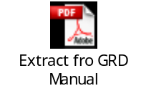
 |  | - 1.1.14 - Product and Process Development - Grant for R&D Checklist for projects starting on or after 1 August 2008. |  |  |  |  |  |  |  |  |  |  | Go to Section 5.4 (Grant for R&D) of Checklist.  See above re Grant for R&D.
 |  | - 1.1.16 - RTD Centres of Excellence Development - RTD CoE Checklist for projects starting on or before 31 July 2008 and Grant for R&D Checklist for projects starting on or after 1 August 2008. |  |  |  |  |  |  |  |  |  |  | Go to Sections 5.5 (RTD Centres of Excellence/Start) or 5.4 (Grant for R&D) of Checklist, as appropriate.  See above re Grant for R&D.
 |  | - 1.1.18 - Start - Start Checklist for projects starting on or before 31 July 2008 and Grant for R&D Checklist for projects starting on or after 1 August 2008. |  |  |  |  |  |  |  |  |  |  | Go to Sections 5.5 (RTD Centres of Excellence/Start) or 5.4 (Grant for R&D) of Checklist, as appropriate.  See above re Grant for R&D.
 |  | - 1.1.19 - Grant for Research and Development - Grant for R&D Checklist to be completed. |  |  |  |  |  |  |  |  |  |  | Go to Section 5.4 of Checklist.  See above re Grant for R&D.
 |  | - 2.1.2 - Northern Ireland Screen - NI Screen Checklist to be completed. |  |  |  |  |  |  |  |  |  |  | Go to Section 5.6 of Checklist.
 |  | DETI Telecoms:
 |  | - 3.1.3 - Next Generation Networks - NGN Checklist to be completed. |  |  |  |  |  |  |  |  |  |  | Go to Section 5.7 of Checklist.
 | 5.1.5 | The following schemes are subject to the State Aid General Block Exemption Regulations (GBER), therefore, the GBER checklist should be completed:
 |  | Invest NI:
 |  | - 1.1.2 - BITP |  |  |  |  |  |  |  |  |  |  | Go to Section 5.10 of Checklist
 |  | - 1.1.20 - Interim Management Programme |  |  |  |  |  |  |  |  |  |  | X424/2009 Go to Section 5.10 of Checklist
 |  | - 1.1.21 - ICT Awareness |  |  |  |  |  |  |  |  |  |  | Go to Section 5.10 of Checklist
 |  | - 1.1.22 - MIS |  |  |  |  |  |  |  |  |  |  | Go to Sections 5.8 (Pre 2009) or 5.9 (Post 2009) of Checklist, as appropriate.
 |  | - 2.1.3 - Selective Financial Assistance |  |  |  |  |  |  |  |  |  |  | Go to Section 5.10 of Checklist
 |  | - 3.4.1 - EREF |  |  |  |  |  |  |  |  |  |  | Go to Section 5.10 of Checklist
 |  | NITB:
 |  | - 2.3.3 - Tourism Innovation Fund |  |  |  |  |  |  |  |  |  |  | Go to Section 5.10 of Checklist
 |  | DETI Telecoms:
 |  | - 3.1.1 - Broadband Fund |  |  |  |  |  |  |  |  |  |  | Go to Section 5.10 of Checklist
 |  | DETI Energy:
 |  | - 3.2.1 - Action Renewables |  |  |  |  |  |  |  |  |  |  | Go to Section 5.10 of Checklist
 |  | DARD:
 |  | - 3.3.1 - Biomass Challenge Fund |  |  |  |  |  |  |  |  |  |  | Go to Section 5.10 of Checklist
Sub-Section 5.2: De Minimis Rule
1998/06 | 5.2.1 | At Scheme level:
 |  | - Does the Scheme operate on the basis of Commission Regulation 1998/2006 (ie the ‘De Minimis’ Regulation)?
 |  | - Was the aid beneficiary informed in advance that the aid being provided was De Minimis?
 | 5.2.2 | At Beneficiary level:
 |  | - Is the beneficiary in receipt of any other De Minimis support? If yes, did the beneficiary confirm that the €200,000 De Minimis ceiling was not exceeded when additional De Minimis Aid was added to existing De Minimis aid.
 | 5.2.3 | Is the enterprise is also involved in the fishery and aqua-culture sectors or active in the primary production of products listed in Annex I of TFEU? If yes, confirm that:  - The aid is being used solely for the processing and marketing of agricultural products and is not being used for fishery and aqua-culture or the primary production of agricultural products;  - The amount of the aid is NOT fixed on the basis of the price or quantity of such products purchased from primary producers or put on the market by the undertakings concerned; and  - The aid is NOT conditional on being partly or entirely passed on to primary producers?
 | 5.2.4 | Confirm that the enterprise is not active in the coal sector (Regulation 1407/2002)?
 | 5.2.5 | Confirm that the aid is not given for export related activities? (Commission decision (2003/595/EC) refers. This was as a result of a test case relating to a German aid scheme to sell and export products from the land of Mecklenburg- Western Pomerania.  The following costs were ruled as eligible:  A – Market-launch activities - ie advice on developing marketing objectives for specific companies, advice on drawing up marketing plans, product styling, pricing, advertising etc. Advice on presenting and demonstrating prototypes, advice on operating commodities exchanges and workshops to improve exports, develop new sales and co-operation opportunities etc; and  B – Participation in fairs and exhibitions in Member State and abroad - ie expenditure directly necessary for the establishment and operation of stands (hire, construction costs, connection to electricity and water supplies, waste disposal, advertising for events, interpretation, transport and insurance).  The following costs were ruled as ineligible:  C – Offices shared abroad - ie expenditure directly necessary for the establishment and operation of shared offices (non fixed office equipment and machines, expenditure on current business necessities, expenditure on foreign staff with a view to set and operate a shared office); and  D – Foreign trade assistants - ie the gross salary liable to wage and income tax of one foreign assistant for one year.
 | 5.2.6 | Confirm that the aid is not granted to an undertaking in difficulty?
 | 5.2.7 | Confirm that the total amount (all aid schemes) of aid granted to the related enterprise does not exceed €200 000 (or €100 000 for road transport sector) over any period of 3 fiscal years?  Check initially the value of the current LoO converting the sterling amount to the euro rate at the date the LoO issued. Rates can be found by accessing the link below.  You should also check the financial statement of the enterprise under ‘received grants’ to ascertain whether other De Minimis aid has been received. Use audited accounts where possible but if not available, base calculations on management accounts and these can be confirmed at a later date to audited accounts, if required (ie close to the 3 year threshold).  The ceilings laid down shall be expressed as a cash grant. All figures used shall be gross, that is, before any deduction of tax or charge. Where aid is awarded in a form other than a grant, the aid amount shall be the gross grant equivalent of the aid.  Aid payable in several instalments shall be discounted to its value at the moment of its being granted. The interest rate to be used for discounting purposes and to calculate the gross grant equivalent shall be the reference rate applicable at the time of grant?
 | 5.2.8 | Is it possible to calculate precisely the gross grant equivalent of the aid ex ante (ie before the award of aid) without need to undertake a risk assessment (transparent aid)? If the aid is a normal grant through LoO, the aid will be transparent, ie offers relating to specific actual costs.  Examples of instances where aid is either transparent or not are as follows:  a) Aid comprised in loans is transparent when the gross grant equivalent has been calculated on the basis of market interest rates prevailing at the time of the grant;  b) Aid comprised in capital injections is transparent only if the total amount of the public injection stays below the ceiling;  c) Aid comprised in risk capital measures is transparent only if the scheme provides capital only up to the ceiling; and  d) Aid provided under a guarantee scheme is transparent when the guaranteed part of the underlying loan provided does not exceed €1,500,000 per undertaking (or €750,000 in the road transport sector) and if the guarantee does not exceed 80% of the underlying loan.
Sub-Section 5.3: Notified Aid Schemes - Compete - N92/2003
 | 5.3.1 | Confirm that the LoO is dated before 1 August 2008?
1083/06 | 5.3.2 | Does the state aid paid for the project correspond to the scheme notification as follows:
A78 | (a) | a) Is the grant rate within the following parameters:  - Phase I - total public aid, including ERDF, limited to a maximum £15,000 and 50% gross of approved costs?  - Phase II - total public aid, including ERDF, limited to a maximum £250,000 and 40% gross of approved costs?
 | (b) | Is the project located in Northern Ireland?
 | (c) | Have only eligible costs been financed, ie:  - Personnel costs (researchers, technicians and other supporting staff employed solely on the research activity)?  - Costs of consultancy and equivalent services used exclusively for the research activity, including the research, technical knowledge and patents bought from outside sources?  - Additional overheads incurred directly as a result of the research activity?  - Other operating expenses (eg costs of travel, materials, supplies and similar products) incurred directly as a result of the research activity?  - And, only for projects falling under Phase II, costs of instruments and equipment used solely and on a continual basis (except where transferred commercially) for research activity?
 | (d) | Confirm that the aid is not given for export related activities? (Commission decision (2003/595/EC) refers. This was as a result of a test case relating to a German aid scheme to sell and export products from the land of Mecklenburg- Western Pomerania.  The following costs were ruled as eligible:  A – Market-launch activities - ie advice on developing marketing objectives for specific companies, advice on drawing up marketing plans, product styling, pricing, advertising etc. Advice on presenting and demonstrating prototypes, advice on operating commodities exchanges and workshops to improve exports, develop new sales and co-operation opportunities etc; and  B – Participation in fairs and exhibitions in Member State and abroad - ie expenditure directly necessary for the establishment and operation of stands (hire, construction costs, connection to electricity and water supplies, waste disposal, advertising for events, interpretation, transport and insurance).  The following costs were ruled as ineligible:  C – Offices shared abroad - ie expenditure directly necessary for the establishment and operation of shared offices (non fixed office equipment and machines, expenditure on current business necessities, expenditure on foreign staff with a view to set and operate a shared office); and  D – Foreign trade assistants - ie the gross salary liable to wage and income tax of one foreign assistant for one year.
 | 5.3.3 | Were the payments made only after the Commission approval of the aid scheme, ie 15 July 2003?
A 258 | 5.3.4 | In case an infringement letter was sent out by the Commission, was the payment blocked? The owner of the State Aid Scheme receives and infringement letter via UK Rep. BIS and DETI will also be notified. This has not yet happened in Northern Ireland. |  |  |  |  |  |  |  | N/A
Sub-Section 5.4: Notified Aid Schemes - Grant for R&D - N215/08
 | 5.4.1 | Is the LoO is dated after 1 August 2008?
 | 5.4.2 | Is the grant aid to the project in excess of €3M? if yes, has an individual notification been provided to the Commission (check that projects have not been disaggregated in order to remain below the ceiling)?
 | 5.4.3 | Does the project relate to fundamental research, industrial research and/or experimental development? Please specify.
1083/06 | 5.4.4 | Does the state aid paid for the project correspond to the scheme notification as follows:
A78 | (a) | Aid for R&D Projects  Is the grant rate for an R&D project within the following parameters:
 | (i) | - Fundamental research - up to 100%;  - Industrial research - up to 50%; and  - Experimental development - up to 25%?
 | (ii) | If the beneficiary is an SME, the grant rate in respect of industrial and experimental development can be increased by 10% for medium enterprises and 20% for small enterprises?
 | (iii) | If the following conditions have been respected, the grant rate may be increased by 15%, up to a maximum of 80%, ie  - In case of a collaboration between two independent enterprises, no single undertaking must bear more than 70 % of the eligible costs of the collaboration project, and the project involves at least one SME or is cross-border (NB - while this is allowable under the State Aid notification, it would probably not meet the requirements of the EUSCP)?  - In case of collaboration between an enterprise and a research organisation, the research organisation bears at least 10% of the eligible costs and it has the right to publish the results of the research project insofar as they stem from research implemented by that research organisation?  - The intensity may be increased by 15% percentage points, up to a maximum of 80%, also in case of industrial research, if the results of the project are widely disseminated through free or open source software)?
 | (iv) | - Have only eligible costs been financed, ie:  - Personnel costs?  - Costs of instruments and equipment and costs for building and land, to the extent and for the duration used for the research project?  - Cost of contractual research, technical knowledge and patents bought or licensed from outside sources at market prices?  - Additional overheads incurred directly as a result of the research project and other operating expenses?
 | (v) | Confirm that the aid is not given for export related activities? (Commission decision (2003/595/EC) refers. This was as a result of a test case relating to a German aid scheme to sell and export products from the land of Mecklenburg- Western Pomerania.  The following costs were ruled as eligible:  A – Market-launch activities - ie advice on developing marketing objectives for specific companies, advice on drawing up marketing plans, product styling, pricing, advertising etc. Advice on presenting and demonstrating prototypes, advice on operating commodities exchanges and workshops to improve exports, develop new sales and co-operation opportunities etc; and  B – Participation in fairs and exhibitions in Member State and abroad - ie expenditure directly necessary for the establishment and operation of stands (hire, construction costs, connection to electricity and water supplies, waste disposal, advertising for events, interpretation, transport and insurance).  The following costs were ruled as ineligible:  C – Offices shared abroad - ie expenditure directly necessary for the establishment and operation of shared offices (non fixed office equipment and machines, expenditure on current business necessities, expenditure on foreign staff with a view to set and operate a shared office); and  D – Foreign trade assistants - ie the gross salary liable to wage and income tax of one foreign assistant for one year.
 | (b) | Aid for Technical Feasibility Studies  Is the grant rate for a technical feasibility study preparatory to industrial research or experimental development activities within the following parameters:
 | (i) | For SMEs, 75% for studies preparatory to industrial research activities and 50% for studies preparatory to experimental development activities?
 | (ii) | For large undertakings, 65% for studies preparatory to industrial research activities and 40% for studies preparatory to experimental development activities?
 | (c) | Aid for Industrial Property Rights Costs for SMEs
 | (i) | Was the beneficiary an SME at the time the grant was approved?
 | (ii) | Did the beneficiary undertake an R&D project, with clearly identified R&D stages, in order to determine the maximum level of support?
 | (iii) | Was the granting authority satisfied that worthwhile patent protection is/was likely to be obtained and detailed satisfactory manufacturing and marketing plans have been submitted either by the inventor or by the company to whom the invention is to be licensed?
 | (iv) | Was the grant rate in accordance for those detailed for R&D projects (paragraph 5.4.4 (a) (i) to (iii) above refers)?
 | (v) | Have only eligible costs been financed, ie:  - Costs preceding the grant of the right in the first legal jurisdiction, including costs relating to the preparation, filing and prosecution of the application as well as costs incurred in renewing the application before the right has been granted?  - Translation and other costs incurred in order to obtain the granting or validation of the right in other legal jurisdictions?  - Costs incurred in defending the validity of the right during the official prosecution of the application and possible opposition proceedings, even if such costs occur after the right is granted?
 | (d) | Aid to Young Innovative Enterprises
 | (i) | Have the following conditions to give aid to young innovative enterprises been met - the beneficiary is:  - A small enterprise that has been of existence for less than 6 years at the time when the aid is granted? And  - An innovative enterprise, on the basis that  - The Member State can demonstrate, by means of an evaluation carried out by an external expert, notably on the basis of a business plan, that the beneficiary will in the foreseeable future develop products, services or processes which are technologically new or substantially improved compared to the state of the art in its industry in the Community, and which carry a risk of technological or industrial failure? Or  - The R&D expenses of the beneficiary represent at least 15% of its total operating expenses in at least one of the three years preceding the granting of the aid or in the case of a start-up enterprise without any financial history, in the audit of its current fiscal period, as certified by an external auditor?
 | (ii) | The aid amount is not be higher than €1.25 million (circa £1.1 million at September 2011 - for exchange rates at the date of grant, refer to link below)?
 | (iii) | The beneficiary has received the aid only once during the period in which it qualifies as a young innovative enterprise?
 | (e) | Aid to Advisory and Support Services in Innovation
 | (i) | Is the grant provided ≤ the maximum of €200,000 to SMEs within any three year period on the condition that the service provider benefits from a national or European certification? If the service provider does not benefit from a national or European certification, is the grant ≤ 75 % of the eligible costs?
 | (ii) | Has the aid been used to buy the services at market price (or if the service provider is a non-for-profit entity, at a price which reflects its full costs plus a reasonable margin)? Ensure that aid has not be granted in the form of a reduced price?
 | (iii) | As regards innovation advisory services, have only eligible costs been financed, ie:  - Management consulting;  - Technological assistance;  - Technology transfer services;  - Training; consultancy for acquisition, protection and trade in Intellectual Property Rights and for licensing agreements; consultancy on the use of standards.
 | (iv) | As regards innovation support services, have only eligible costs been financed, ie:  - Office space;  - Data banks;  - Technical libraries;  - Market research;  - Use of laboratory;  - Quality labelling, testing and certification.
 | (f) | Aid for the Loan of Qualified Personnel  Where the grant aid is for the loan of highly qualified personnel seconded from a research organisation or a large enterprise to an SME, have the following conditions been observed:
 | (i) | The seconded personnel is not be replacing other personnel, but is employed in a newly created function within the beneficiary undertaking and has been employed for at least two years in the research organisation or the large enterprise, which is sending the personnel on secondment?
 | (ii) | The seconded personnel works on R&D&I activities within the SME receiving the aid?
 | (iii) | Have only eligible costs been financed, ie personnel costs for borrowing and employing highly qualified personnel, including the costs of using a recruitment agency, as well as a mobility allowance for the seconded personnel?
 | (iv) | Has the maximum aid intensity been observed, ie 50% of the eligible costs, for a maximum of 3 years per undertaking and per person borrowed?
 | 5.4.5 | Is the project located in Northern Ireland?
 | 5.4.6 | Were the payments made only after the Commission approval of the aid scheme, ie 01 August 2008, and before the end date, ie 31 December 2013?
A 258 | 5.4.7 | In case an infringement letter was sent out by the Commission, was the payment blocked? The owner of the State Aid Scheme receives and infringement letter via UK Rep. BIS and DETI will also be notified. This has not yet happened in Northern Ireland. |  |  |  |  |  |  |  |  |  | N/A
Sub-Section 5.5: Notified Aid Schemes - RTD Centre of Excellence and Start - NN54/92
 | 5.5.1 | Is the LoO is dated before 1 August 2008?
 | 5.5.2 | Is the beneficiary a Northern Ireland based Higher Education Institution or Industry?
1083/06 | 5.5.3 | Does the state aid paid for the project correspond to the scheme notification as follows:
A78 | (a) | a) Is the grant rate within the following parameters:  - Fundamental research by Higher Education Institutions up to 100%?  - Basic industrial research conducted by collaborative arrangements between Higher Education Institutions and Industry up to 50%?
 | (b) | Have only eligible costs been financed, ie personnel, overheads, equipment, consumables, travel and consultancy?
 | (c) | Confirm that the aid is not given for export related activities? (Commission decision (2003/595/EC) refers. This was as a result of a test case relating to a German aid scheme to sell and export products from the land of Mecklenburg- Western Pomerania.  The following costs were ruled as eligible:  A – Market-launch activities - ie advice on developing marketing objectives for specific companies, advice on drawing up marketing plans, product styling, pricing, advertising etc. Advice on presenting and demonstrating prototypes, advice on operating commodities exchanges and workshops to improve exports, develop new sales and co-operation opportunities etc; and  B – Participation in fairs and exhibitions in Member State and abroad - ie expenditure directly necessary for the establishment and operation of stands (hire, construction costs, connection to electricity and water supplies, waste disposal, advertising for events, interpretation, transport and insurance).  The following costs were ruled as ineligible:  C – Offices shared abroad - ie expenditure directly necessary for the establishment and operation of shared offices (non fixed office equipment and machines, expenditure on current business necessities, expenditure on foreign staff with a view to set and operate a shared office); and  D – Foreign trade assistants - ie the gross salary liable to wage and income tax of one foreign assistant for one year.
 | 5.5.4 | Is the total project amount less than ECU 20 million? If no, has an individual notification been submitted to the Commission and in a timely manner?
A 258 | 5.5.5 | In case an infringement letter was sent out by the Commission, was the payment blocked? The owner of the State Aid Scheme receives and infringement letter via UK Rep. BIS and DETI will also be notified. This has not yet happened in Northern Ireland. |  |  |  |  |  |  |  | N/A |  |  | Has not yet happened in Northern Ireland. How do we easily confirm this remains the case?
Sub-Section 5.6: Notified Aid Schemes - NI Screen - N353/2003, N504/2006, N593/2006, N214/2008, N70/2009, N550/2010
 | 5.6.1 | Does the state aid paid for the project correspond to the scheme notification as follows:
A78 | (a) | Is the grant rate within the following parameters:  - The total aid has not exceeded the notified value of £51.5 million?  - The scheme has operated between 1 April 2007 and 31 March 2012?
 | (b) |  | The following aid intensity has been observed:
  Element of Screen Fund | Maximum Proportion of Budget
  Development | 90%
  Production | 50%
  Irish Language/ Ulster-Scots Development | 90%
  Irish Language/ Ulster-Scots Production | Up to 75%
 | (c) |  | Is the project located in Northern Ireland?
 | (d) |  | Confirm that the aid is not given for export related activities? (Commission decision (2003/595/EC) refers. This was as a result of a test case relating to a German aid scheme to sell and export products from the land of Mecklenburg- Western Pomerania.  The following costs were ruled as eligible:  A – Market-launch activities - ie advice on developing marketing objectives for specific companies, advice on drawing up marketing plans, product styling, pricing, advertising etc. Advice on presenting and demonstrating prototypes, advice on operating commodities exchanges and workshops to improve exports, develop new sales and co-operation opportunities etc; and  B – Participation in fairs and exhibitions in Member State and abroad - ie expenditure directly necessary for the establishment and operation of stands (hire, construction costs, connection to electricity and water supplies, waste disposal, advertising for events, interpretation, transport and insurance).  The following costs were ruled as ineligible:  C – Offices shared abroad - ie expenditure directly necessary for the establishment and operation of shared offices (non fixed office equipment and machines, expenditure on current business necessities, expenditure on foreign staff with a view to set and operate a shared office); and  D – Foreign trade assistants - ie the gross salary liable to wage and income tax of one foreign assistant for one year.
A 258 | 5.6.2 |  | In case an infringement letter was sent out by the Commission, was the payment blocked? The owner of the State Aid Scheme receives and infringement letter via UK Rep. BIS and DETI will also be notified. This has not yet happened in Northern Ireland. |  |  |  |  |  |  |  | N/A
Sub-Section 5.7: Notified Aid Schemes - Next Generation Broadband - N418/2009
1083/06 | 5.7.1 |  | Does the state aid paid for the project correspond to the scheme notification as follows:
A78 | (a) |  | a) Is the grant rate within the following parameters:  - The total aid has not exceeded the expected value of £18 million?  - Total public aid, including ERDF, limited to a maximum of 40% gross of approved costs?  - The scheme has operated between 1 November 2009 and 31 December 2013?  - The aid was allocated on the basis of an open tender (also complete the procurement checklist)?
 | (b) |  | Is the project located in Northern Ireland?
 | (c) |  | Confirm that the aid is not given for export related activities? (Commission decision (2003/595/EC) refers. This was as a result of a test case relating to a German aid scheme to sell and export products from the land of Mecklenburg- Western Pomerania.  The following costs were ruled as eligible:  A – Market-launch activities - ie advice on developing marketing objectives for specific companies, advice on drawing up marketing plans, product styling, pricing, advertising etc. Advice on presenting and demonstrating prototypes, advice on operating commodities exchanges and workshops to improve exports, develop new sales and co-operation opportunities etc; and  B – Participation in fairs and exhibitions in Member State and abroad - ie expenditure directly necessary for the establishment and operation of stands (hire, construction costs, connection to electricity and water supplies, waste disposal, advertising for events, interpretation, transport and insurance).  The following costs were ruled as ineligible:  C – Offices shared abroad - ie expenditure directly necessary for the establishment and operation of shared offices (non fixed office equipment and machines, expenditure on current business necessities, expenditure on foreign staff with a view to set and operate a shared office); and  D – Foreign trade assistants - ie the gross salary liable to wage and income tax of one foreign assistant for one year.
A 258 | 5.7.2 |  | In case an infringement letter was sent out by the Commission, was the payment blocked? The owner of the State Aid Scheme receives and infringement letter via UK Rep. BIS and DETI will also be notified. This has not yet happened in Northern Ireland. |  |  |  |  |  |  |  | N/A
Sub-Section 5.8: SME Block Exemption - Pre-2009 (ie LoO Issue Date Up to and Including 31 December 2008) - MIS - XS 171/2008
Regulation 1628/2006 | 5.8.1 |  | With regard to the scope of the Regulation, can you confirm that it is a transparent aid scheme (transparent means it is possible to calculate precisely the gross grant equivalent as a percentage of eligible expenditure. Public loans are considered transparent provided that they are backed by normal security and do not involve abnormal risk, ie not subsidised or state guaranteed)?
Commission Regulation (EC) No 70/2001 | 5.8.2 |  | Does the company to whom the aid is granted fulfil the SME requirements (less than 250 employees and annual turnover of less than €50M or Balance Sheet total of less than €43M - the criteria must be applied to company as a whole (including subsidiaries located in other MS and outside the EU)?
1998/06 | 5.8.3 |  | Is the enterprise is also involved in the fishery and aqua-culture sectors or active in the primary production of products listed in Annex I of TFEU? If yes, confirm that:  - The aid is being used solely for the processing and marketing of agricultural products and is not being used for fishery and aqua-culture or the primary production of agricultural products;  - The amount of the aid is NOT fixed on the basis of the price or quantity of such products purchased from primary producers or put on the market by the undertakings concerned; and  - The aid is NOT conditional on being partly or entirely passed on to primary producers?
 | 5.8.4 |  | Confirm that the aid is not given for export related activities? (Commission decision (2003/595/EC) refers. This was as a result of a test case relating to a German aid scheme to sell and export products from the land of Mecklenburg- Western Pomerania.  The following costs were ruled as eligible:  A – Market-launch activities - ie advice on developing marketing objectives for specific companies, advice on drawing up marketing plans, product styling, pricing, advertising etc. Advice on presenting and demonstrating prototypes, advice on operating commodities exchanges and workshops to improve exports, develop new sales and co-operation opportunities etc; and  B – Participation in fairs and exhibitions in Member State and abroad - ie expenditure directly necessary for the establishment and operation of stands (hire, construction costs, connection to electricity and water supplies, waste disposal, advertising for events, interpretation, transport and insurance).  The following costs were ruled as ineligible:  C – Offices shared abroad - ie expenditure directly necessary for the establishment and operation of shared offices (non fixed office equipment and machines, expenditure on current business necessities, expenditure on foreign staff with a view to set and operate a shared office); and  D – Foreign trade assistants - ie the gross salary liable to wage and income tax of one foreign assistant for one year.
 |  |  | Aid for Investment
Article 4.2 | 5.8.5 |  | Regarding aid for investment in tangible and intangible assets, is the gross aid intensity equal to/less than:  (a) 15% for small enterprises; and  (b) 7.5% for medium-sized enterprises?  An investment is any type of grant aid to a project.
Article 4.3 | 5.8.6 |  | Is the grant aid within regional aid ceilings (ie Northern Ireland is qualifies for regional aid of 30% up to 31 December 2010 and up to 15% thereafter - regional aid map at Annex II refers)?
Article 4.4 | 5.8.7 |  | Is the grant aid calculated either as a percentage of the investment's eligible costs or as a percentage of the wage costs of employment created by the carrying-out of an investment (aid to job creation) or a combination thereof (the aid should not exceed the most favourable amount resulting from the application of either calculation)?
Article 4.5 | 5.8.8 |  | Is the grant aid calculated on the basis of the investment's costs? If yes:  - Are the eligible costs of tangible investment the costs relating to investment in land, buildings, machinery and equipment (in the transport sector, except for railway rolling stock, transport means and transport equipment shall not be included in the eligible costs)? or  - Are the eligible costs of intangible investment the costs of acquisition of the technology?
Article 4.6 | 5.8.9 |  | Is the grant aid is calculated on the basis of jobs created? If yes, is the amount of the grant aid expressed as a percentage of the wage costs over a period of two years relating to the employment created under the following conditions:  (a) Job creation is linked to the carrying-out of a project of investment in tangible or intangible assets and jobs have been created within three years of the investment's completion;  (b) The investment project leads to a net increase in the number of employees in the establishment concerned, compared with the average over the previous twelve months; and  (c) The employment created will be/has been maintained during a minimum period of five years?
 |  |  | Consultancy and Other Services and Activities
Article 5 (a) | 5.8.10 |  | Is the grant aid for services provided by outside consultants. If yes, is the gross aid less than or equal to 50% of the costs of such services (the services concerned shall not be a continuous or periodic activity nor relate to the enterprise's usual operating expenditure, such as routine tax consultancy services, regular legal services, or advertising)?
Article 5 (b) | 5.8.11 |  | Is the grant aid for participation in fairs and exhibitions. If yes, is the gross aid less than or equal to 50% of the additional costs incurred for renting, setting up and running the stand (this exemption only applies to the first participation of an enterprise in a particular fair or exhibition)?
Sub-Section 5.9: MIS - 2009 onward (ie LoO Issue Date from 5 January 2009 - 31 December 2013) - XS 423/2009
Regulation 1628/2006 | 5.9.1 |  | With regard to the scope of the Regulation, can you confirm that it is a transparent aid scheme (transparent means it is possible to calculate precisely the gross grant equivalent as a percentage of eligible expenditure. Public loans are considered transparent provided that they are backed by normal security and do not involve abnormal risk, ie not subsidised or state guaranteed)?
Regulation 800/08 A8 | 5.9.2 |  | Has the aid an incentive effect (ie before work on the project or activity has started, the beneficiary has submitted an application for the aid to the Member State concerned)?
A13 |  |  | Regional Investment and Employment Aid
 | 5.9.3 |  | Has ad hoc aid been granted (ie aid over and above the MIS Scheme)? If yes, is the ad hoc aid less than or equal to 50% of the total aid granted?
 | 5.9.4 |  | Can you confirm that the aid intensity (total public aid including ERDF) stays below the agreed ceiling:  To confirm that the project is within Belfast, refer to the Postcodes tables provided in TRIM Document No: DT1/11/0095036
  January 2007 - December 2010
  Enterprise:
  Large |  | Medium |  | Small
  30% |  | 40% |  | 50%
  January 2011 - December 2013
  Enterprise:
  Belfast | 10% |  | 20% |  | 30%
  Other | 15% |  | 25% |  | 35%
 | 5.9.5 |  | Confirm the project has not been artificially divided into sub-projects in order to prevent a large investment (a large investment project is considered to be a single investment project when the investment is undertaken within a period of three years by the same undertaking or undertakings and consists of fixed assets combined in an economically indivisible way).
A26/27 |  |  | Aid for Consultancy in favour of SMEs
 | 5.9.6 |  | Is the grant aid for services provided by outside consultants. If yes, is the gross aid less than or equal to 50% of the costs of such services (the services concerned shall not be a continuous or periodic activity nor relate to the enterprise's usual operating expenditure, such as routine tax consultancy services, regular legal services, or advertising)?
 | 5.9.7 |  | Is the grant aid for participation in fairs and exhibitions. If yes, is the gross aid less than or equal to 50% of the additional costs incurred for renting, setting up and running the stand (this exemption only applies to the first participation of an enterprise in a particular fair or exhibition)?
 | 5.9.8 |  | Confirm that the services concerned are not a continuous or periodic activity nor relate to the undertaking’s usual operating costs, such as routine tax consultancy services, regular legal services or advertising.
A39(2) |  |  | Training Aid
 | 5.9.9 |  | Is the grant aid for general training (ie training involving tuition which is not applicable only or principally to the employee’s present or future position in the undertaking, but which provides qualifications that are largely transferable to other undertakings or fields of work).
 | 5.9.10 |  | Is the grant aid intensity less than or equal to:  - 60% of the eligible cost; or  - 70% for disabled or disadvantaged workers; or  - 70% if awarded to a medium sized enterprise; or  - 80% for a small enterprise?  Please specify.
 | 5.9.11 |  | Are eligible costs of training restricted to:  (a) trainers’ personnel costs;  (b) trainers’ and trainees’ travel expenses, including accommodation;  (c) other current expenses such as materials and supplies directly related to the project;  (d) depreciation of tools and equipment, to the extent that they are used exclusively for the training project;  (e) cost of guidance and counselling services with regard to the training project;  (f) trainees’ personnel costs and general indirect costs (administrative costs, rent, overheads) up to the amount of the total of the other eligible costs referred to in points (a) to (e). As regards the trainees’ personnel costs, only the hours during which the trainees actually participate in the training, after deduction of any productive hours, may be taken into account.
Sub-section 5.10 - Regional Investment Aid Block - SFA (XR 11/2007) and NI Broadband Fund (XR 116/08)
Regulation 1628/2006 | 5.10.1 |  | With regard to the scope of the Regulation, can you confirm that it is a transparent aid scheme (transparent means it is possible to calculate precisely the gross grant equivalent as a percentage of eligible expenditure. Public loans are considered transparent provided that they are backed by normal security and do not involve abnormal risk, ie not subsidised or state guaranteed)?
 | 5.10.2 |  | Is the enterprise is also involved in the fishery and aqua-culture sectors or active in the primary production of products listed in Annex I of TFEU? If yes, confirm that:  - The aid is being used solely for the processing and marketing of agricultural products and is not being used for fishery and aqua-culture or the primary production of agricultural products;  - The amount of the aid is NOT fixed on the basis of the price or quantity of such products purchased from primary producers or put on the market by the undertakings concerned; and  The aid is NOT conditional on being partly or entirely passed on to primary producers?
 | 5.10.3 |  | Confirm that the aid is not given for export related activities? (Commission decision (2003/595/EC) refers. This was as a result of a test case relating to a German aid scheme to sell and export products from the land of Mecklenburg- Western Pomerania. The following costs were ruled as eligible:  A – Market-launch activities - ie advice on developing marketing objectives for specific companies, advice on drawing up marketing plans, product styling, pricing, advertising etc. Advice on presenting and demonstrating prototypes, advice on operating commodities exchanges and workshops to improve exports, develop new sales and co-operation opportunities etc; and  B – Participation in fairs and exhibitions in Member State and abroad - ie expenditure directly necessary for the establishment and operation of stands (hire, construction costs, connection to electricity and water supplies, waste disposal, advertising for events, interpretation, transport and insurance).  The following costs were ruled as ineligible:  C – Offices shared abroad - ie expenditure directly necessary for the establishment and operation of shared offices (non fixed office equipment and machines, expenditure on current business necessities, expenditure on foreign staff with a view to set and operate a shared office); and  D – Foreign trade assistants - ie the gross salary liable to wage and income tax of one foreign assistant for one year.)
 | 5.10.4 |  | Can you confirm that the aid or the scheme is:
 | (a) |  | Not targeting specific sectors of economic activity within manufacturing or services (except tourism)?
 | (b) |  | Not providing for operating aid (ie normal running costs)?
 | (c) |  | Not providing for aid other than investment or consultancy aid?
 | (d) |  | Not in favour of large investment projects (if total sum of aid > 75% of maximum aid an investment with €100M eligible cost could receive)?
 | (e) |  | Not for a beneficiary subject to an outstanding recovery order?
 | (f) |  | Not for ad hoc aid (other than the one exempted)?
 | 5.10.5 |  | Can you confirm that the aid intensity (total public aid including ERDF) stays below the agreed ceiling:  To confirm that the project is within Belfast, refer to the Postcodes tables provided in TRIM Document No: DT1/11/0095036
  January 2007 - December 2010
  Enterprise:
  Large |  | Medium |  | Small
  30% |  | 40% |  | 50%
  January 2011 - December 2013
  Enterprise:
  Belfast | 10% |  | 20% |  | 30%
  Other | 15% |  | 25% |  | 35%
 | 5.10.6 |  | Has the investment been maintained for at least 5 years?
 | 5.10.7 |  | Is the company providing its own contribution (own funds or public support free external funding such as loans) of at least 25%?
 | 5.10.8 |  | Is the aid provided for initial investment only (ie setting-up of a new establishment, extension of existing establishment, diversification of output into new additional products, fundamental change in production process or acquisition of capital assets directly linked to an establishment which has closed or would have closed had it not been purchased and the assets are bought by an independent investor. NB Sole acquisition of shares is not an initial investment)?
 | 5.10.9 |  | In case of immaterial assets being purchased, confirm that they are (immaterial assets are assets entailed by the transfer of technology through the acquisition of patent rights, licences, know-how or unpatented technical knowledge):
 | (a) |  | Used exclusively in the establishment receiving the aid?
 | (b) |  | Regarded as amortisable assets (active side of the Balance Sheet)?
 | (c) |  | Purchased from third parties under market conditions?
 | (d) |  | Included in the assets of the firm and remain in the firm receiving the aid for 5 years, or 3 years in the case of SMEs?
 | 5.10.10 |  | Are the assets purchased new (except for takeovers and SMEs)?
 | 5.10.11 |  | Before the start of the work:  - Was a project application was submitted?  - Did the authority responsible for the admin of the scheme confirm in writing that, subject to the final outcome of a detailed verification, the project meets the conditions of eligibility?
 | 5.10.12 |  | In case the aid is calculated as a percentage of the wage costs:
 | (a) |  | Jobs were directly created by an investment project?
 | (b) |  | Jobs were created within 3 years of the investment's completion and are/will be maintained for a minimum period of 5 years, or 3 years in the case of SMEs?
Conclusion: Have State Aid Rules been fully observed? If no, please explain below: |  |  |  |  |  |  |  |  |  |  |  |  |  |  |  | Y/N
Section 6 - Public Procurement
Source/ Regulation | No |  | Audit Step |  | Yes |  |  | No |  |  | N/A |  |  | Comment |  | Ref
 |  |  | For this section please use the separate Public Procurement checklist
Conclusion: Have Public Procurement Rules been respected? If no, please explain below: |  |  |  |  |  |  |  |  |  |  |  |  |  |  |  | Y/N
Section 7 - Overall Conclusion
Conclusion: Summarise by providing an overall conclusion below. Also, provide details of all findings to be brought forward to the report and record whether systemic issues have been detected:

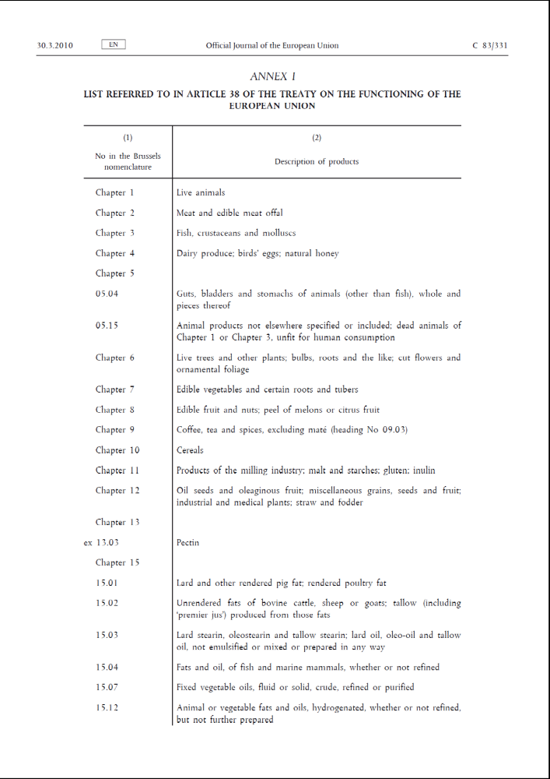
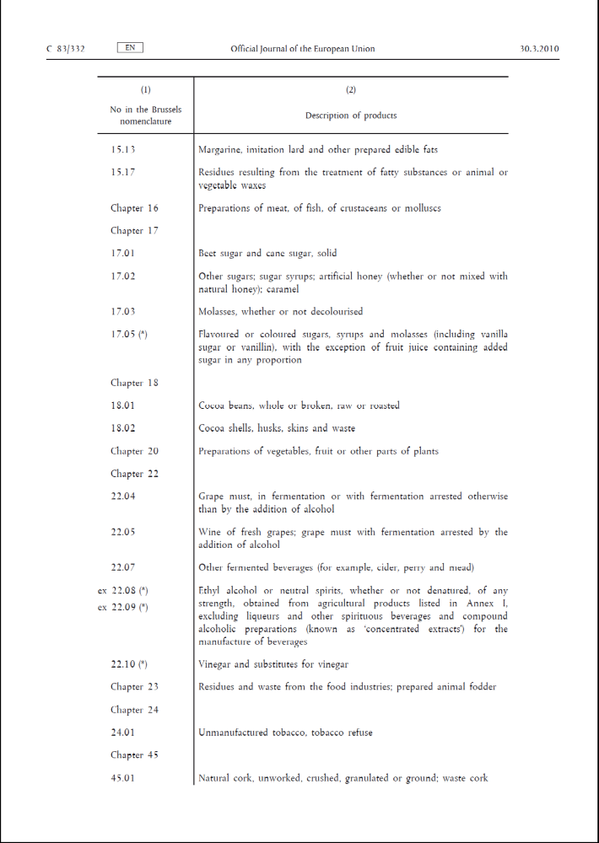
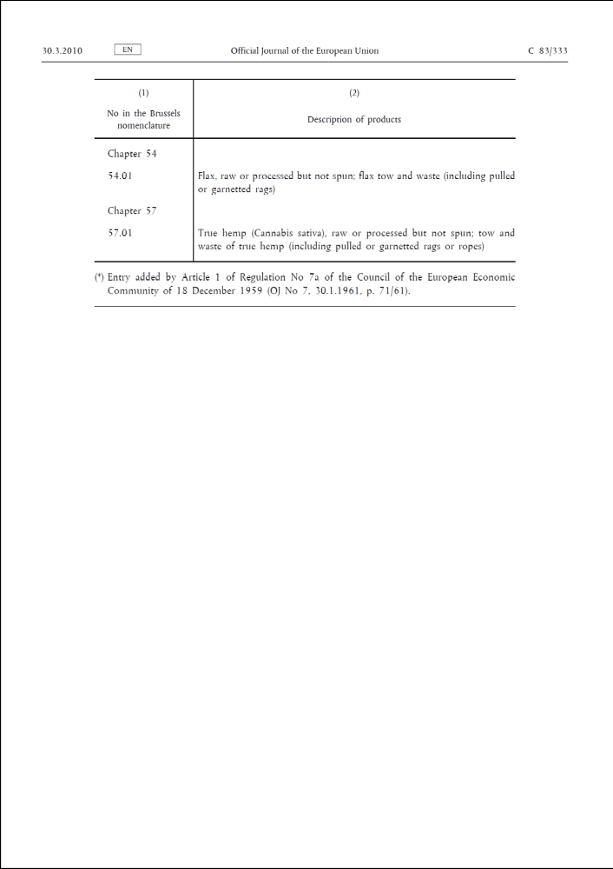

http://ec.europa.eu/budget/inforeuro/index.cfm?fuseaction=currency_historique&currency=72&Language=en
- http://ec.europa.eu/budget/inforeuro/index.cfm?fuseaction=currencyhistorique&currency=72&Language=en)?

